DPC/S4.43

ACROSS GOVERNMENT STANDARD

Problem Management Standard
Purpose
The purpose of this document is to describe the Problem Management Process to be used by all SA Government Agencies and Suppliers when undertaking problem management within the StateNet environment.
Scope
This standard applies to all South Australian Government Public Sector agencies, suppliers and Office of the Chief Information Officer (OCIO) staff that undertake problem management within the StateNet environment.
Standard Detail
The across government problem management process will oversee the management of problem records between the State and its suppliers which impact, or potentially impact, more than one agency for the services as listed in the OCIO Services Portal.

ITIL defines a problem as a cause of one or more incidents. The cause is not usually known at the time a Problem Record is created, and the Problem Management Process is responsible for further investigation.

Problem Management is the process responsible for managing the lifecycle of all problems. Problem Management proactively prevents incidents from happening and minimizes the impact of incidents that cannot be prevented.
Problem Management Concepts
A known error is defined as a problem with a documented root cause and workaround.

Benefits
This process enables:

- Higher availability of IT services by reducing the number and duration of incidents
- Higher productivity of IT staff by reducing unplanned labour caused by incidents and creating the ability to resolve incidents more quickly via the mechanisms of known errors and workarounds.

Problems are usually identified and requested by the OCIO Across Government Service Desk (AGSD) Service Management team and Service Owners. Generally, they are raised from incidents and major incidents and are concerned with identifying and approving root cause, workarounds, and solutions.

The AGSD Service Management team will raise the problem in the OCIO ITSM (IT Service Management) tool, own the problem and assign tasks to suppliers and Service Owners to complete the required work.

The problem record is owned by the AGSD Service Management team who is responsible for assigning tasks to defined groups and individuals to complete pieces of work.

Across Government Problem Management Process
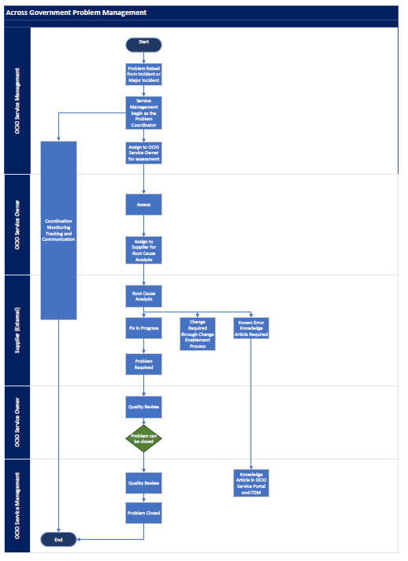
Roles and Responsibilities Across Government Problem Management
 | Process  State | Description | ORM | Supplier | Across Government Service Management | OCIO Service  Owners
1 | New | The problem is raised by the OCIO AGSD Service Management team in ITSM.  A task is assigned to OCIO Service Owner to work with the Supplier/s requesting root cause and work around. |  |  | X | X
2 | Assessment | The Service Owner assesses the Problem and engages with the supplier/s to request Root Cause Analysis, work around and problem fix. |  | X
3 | Root Cause Analysis | The Service Owner assigns for Root Cause Analysis to determine the fix.  The supplier will be advised on the task and identify the solution. This is done in consultation with the service owner.  When Root Cause Analysis is completed, and solution is agreed on by supplier and service owner the problem record is moved to Fix state by the Service Owner. |  | X | X | X
4 | Fix | Fix details are reviewed by service management group for quality check and any action required.  Once an appropriate solution is agreed, the supplier will document this, and complete the task. This may include:  - Fix to be implemented by the Supplier/s.  - Change to be created through Change Enablement process.  - Known Error, knowledge article required.  The Problem may require to be reanalysed if fix is not satisfactory.  Service Owner will move to next state when complete. |  |  | X | X
5 | Resolved | Once the service owner is satisfied that the solution has resolved the problem, they move the problem on to the next status and assign to the AGSD Service Management team to review advise stakeholders on Problem resolutions and upload any knowledge articles required. |  |  | X | X
11 | Closed | The problem is closed. Closed problems  can’t be reopened. |  |  | X
Related documents
- Across Government Problem Management Flow Chart

DOCUMENT CONTROL
Approved by: Paul Tracey, Director Infrastructure and Customer Service, Office of the Chief
Information Officer (OCIO)
Contact: OCIO Service Delivery Manager | Email: joanne.romeo@sa.gov.au
Division: Infrastructure and Customer Service | Compliance: Mandatory
Review number: | Date of approval: 28 March 2024
Next review date: March 2025 | Objective Id: B1747668

