PC/S4.44

ACROSS GOVERNMENT STANDARD

Incident Management Process Standard
Purpose
The purpose of this document is to describe the Incident Management process to be used by all South Australian Government Agencies and Suppliers when engaged in Incident Management within the StateNet environment.

Scope
This standard applies to all South Australian Government Public Sector agencies, Suppliers and Office for the Chief Information Officer (OCIO) staff that are engaged in incident management within the StateNet environment.
Standard Detail
The Across Government Incident Management Process will oversee the management of incidents affecting the State, Agencies and Suppliers for services listed in the Service Catalogue on the OCIO Services Portal.

All incidents are owned’ by the Across Government Service Desk (AGSD) who are responsible for assigning tasks to defined groups and individuals to resolve.
Incident Management Concepts
An ‘Incident’ is defined by ITIL® as “an unplanned interruption to an IT service or reduction in the quality of an IT service”. Failure of a configuration item that has not yet impacted service is also an incident, for example failure of one disk from a mirror set.
Major Incident (MI)- occurs when an incident is upgraded due to complete loss of a critical service or significant degradation of a critical service affecting one or more agencies. It is an incident with the highest-impact and highest-urgency. A major incident is defined as an event which has significant impact or urgency for the business/organisation, and which demands a response beyond the routine incident management process.
“Major Incidents” managed under the process specified in this document are defined as:
Across Government incidents that impact, or have the potential, to impact on the functions of a single or multiple agencies.
A major incident (MI) impact may result in significant disruption to the business units impacted and demands a response beyond the routine incident management process.
SA Government Agencies rely on the State’s across-government ICT Infrastructure to deliver services to their constituents and to provide essential internal business functions for their Agency.

Incident management is the process responsible for managing the lifecycle of all incidents.

Benefits
This process enables:

- The ability to reduce unplanned labour and costs caused by incidents.
- Lower downtime to the business resulting in higher availability
- Identify potential improvements to services.
- Identify additional service or training requirements.

Priorities
Incident priority is determined by a number of factors:

- Contractual requirements
- Impact/scope of the incident (how many end users/agencies does it affect)
- Political ramifications
- Operations
- Urgency.

Incidents are allocated a priority defined by identifying impact and urgency. The priorities range from 1 being the highest to 4 being the lowest. Multi-site incidents will normally be priority 1 or 2 and considered a Major Incident. All major incidents will be recorded and classified in the OCIO Service Management system and discussed/communicated via a variety of forums.

Incident priority may also be defined through contractual agreements with suppliers. There may be P1 incidents of a single site nature that are reported and managed to an appropriate group of stakeholders.

The Across Government Service Desk provides first and second level Incident Management for a range of services. These incidents are generally single user or single site incidents. If an incident is reported to or identified by a third-party supplier, the Incident is raised in the Supplier Service Management tool and the responsibility is for the supplier to notify AGSD Service Management team who will assess with other reported Incidents to determine if incident is across multiple suppliers.

The Across Government Service Desk, Service Management team provides a communication and coordination function within Incident Management for multi-site and multi-agency incidents. This is considered Major Incident Management. This category of incident may be reported to the supplier by the agency or identified by the suppliers themselves (including OCIO).
If a major incident is identified by a third-party supplier, The Incident is raised in the Supplier Service Management tool and the responsibility is for the supplier to notify AGSD Service Management team address who then perform the functions of communication and coordination.
The AGSD Service Management team raises a corresponding Major Incident in the OCIO Service Management tool and takes ownership for ensuring the incidents are progressing and updates are provided in a timely manner.
Post Incident Report is a report produced after the resolution a major incident that analyses how the AGSD Service Management team and/or suppliers involved in an incident handled the incident as it progressed.

A Problem Record is raised using the problem management process. A problem is an unknown cause of one or more incidents which requires more in-depth investigation where no underlying cause has been identified.
Incident Model is a way of predefining the steps that should be taken for handling particular types of incidents (those that are not new – have occurred in the past and are likely to occur in the future).

The status of an incident reflects the current position in its lifecycle, sometimes known as its 'workflow position'. All incidents logged in the support system will have the relevant status applied at each stage of its progression toward closure. The ‘Status’ field in the support system is a mandatory field.

Incident & Major Incident States
The following state codes will be used for Incidents logged with the Across Government Service Desk.

Incident State Code | Description
New | This is the system default when a ticket is first opened and indicates that the incident is logged but no action has been taken.
In Progress | This state indicates that incident investigation has commenced that a possible solution has been found and work is in progress to develop the solution. In Progress can indicate that the Incident has been sent to an OCIO resolver group.
On Hold | This can indicate the incident is with the third-party supplier or vendor for further investigation, repair, or replacement. This state is also applied when awaiting some further action from the Agency to enable a solution
Resolved | This state indicates that the incident has a solution and is awaiting final approval and/or feedback from the customer prior to closure.
Cancelled | This state applied when the requesting Agency Service Desk advises that the ticket raised in no longer required.
Closed | Indicates that the incident is resolved, and the customer is satisfied with the resolution.

Across Government Incident and Major Incident Process
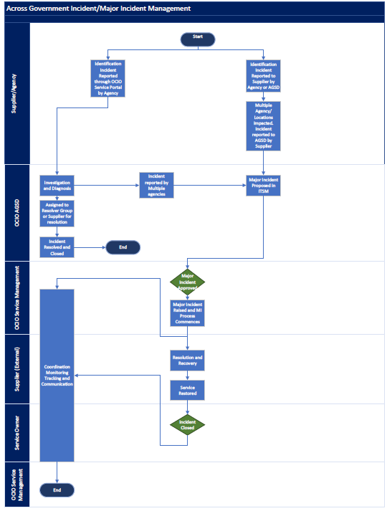

Roles and Responsibilities - Across Government Incident Management
 | Process State | Description | Agency Service Desk | Supplier | Across Government Service Desk  Desk | OCIO Resolver Group
1 | New | This state is assigned when the Agency Service Desk reports an Issue to the Across Government Service Desk who raise an Incident or if the Incident has been raised with the supplier.  If the incident has been raised to the supplier, the supplier must advise the AGSD via the supplied email address. | X | X  X | X
2 | In Progress | This state is assigned when the Across Government Service Desk has investigated the Incident and assigned to the relevant OCIO resolver group or supplier for resolution. |  | X | X  X | X
3 | On Hold | This state is assigned when the Across Government Service Desk or resolver group requires more information from Agency Service Desk or if the Incident is awaiting action from with the third-party supplier. | X | X | X
5 | Resolved | This state is assigned when services have been restored or the configuration items have been restored to a functioning state. Further work may occur in the resolved status, but it does not affect the services. |  |  | X  X | X
6 | Closed | This state is the final status in the Incident Management Process. Once this state is assigned the incident cannot be reopened. |  |  | X  X

Roles and Responsibilities – Across Government Major Incident Management
 | Process State | Description | Agency Service Desk | Supplier | Across Government Service Desk  Desk | OCIO Service Management
1 | New | Agency Service Desk raise incident with AGSD or with Supplier.  Supplier advises AGSD of Major Incident or AGSD propose Major Incident as multi-site or multiple agencies have reported incident.  the supplier must advise the AGSD via the supplied email address. | X | X  X | X
2 | In Progress | This state is assigned when the Across Government Major Incident has been raised.  The AGSD Service Management team coordinate, monitor track and communicate the Major Incident.  The Supplier works to restore services. |  | X | X  X | X
3 | On Hold | This state is assigned if the Incident is awaiting action from the third-party supplier, or an Emergency Change has been raised. |  | X | X
5 | Resolved | This state is assigned when services have been restored or the configuration items have been restored to a functioning state. Further work may occur in the resolved status, but it does not affect the services. |  | X | X | X
6 | Closed | This state is the final status in the Major Incident Management Process. The Service Owner declares the MI closed. Once this state is assigned the incident cannot be reopened. |  |  | X  X | X

Related documents
- Across Government Incident and Major Incident Flow Chart

DOCUMENT CONTROL
Approved by: Paul Tracey, Director Infrastructure and Customer Service, Office of the Chief
Information Officer (OCIO)
Contact: OCIO Service Delivery Manager | Email: joanne.romeo@sa.gov.au
Division: Infrastructure and Customer Service | Compliance: Mandatory
Review number: | Date of approval: 28 March 2024
Next review date: March 2025 | Objective Id: B1746795

