DPC/S4.45

ACROSS GOVERNMENT STANDARD

Change Enablement Process Standard
Purpose
The purpose of this document is to describe the change enablement process to be used by all SA Government agencies and suppliers when engaged in Change Enablement within the StateNet environment.
Scope
This standard applies to all South Australian Government Public Sector agencies, Suppliers and OCIO staff undertaking any planned activity, which is an alteration to the current state of StateNet systems or components within the scope of Across Government ICT Change Enablement and is not in a Suppliers Standard Change Catalogue. This includes any Supplier-supported infrastructure covered in the Across Government ICT Change Enablement model.
Standard
The OCIO Across Government Change Enablement Process will oversee the implementation of changes between the State, suppliers and agencies which impact, or potentially impact more than one agency for the services in the OCIO Services Portal.

- Microsoft updates impacting StateNet Environment
- Upgrades to different versions of Windows Operating Systems
- Commissioning or decommissioning Domain Controllers
  - Any activity of change that will or could potentially impact a Windows trust connection
- Any outage, including scheduled reboots.

Changes are raised and requested to OCIO by suppliers and agencies through the OCIO Service Portal.

Agencies may raise ‘Information Only’ changes. These changes are not performed on the StateNet infrastructure however are issues that are identified with potential to affect the StateNet infrastructure and may have impact on other agencies. Examples of ‘Information Only’ changes are planned building power shutdowns, changes to domain controllers and changes on the Justice network that may link into the StateNet services network.
Changes raised for information only will appear in the ‘All Changes’ page of the OCIO Services Portal.

Change Enablement Concepts
Change Enablement is described in ITIL 4 as:

“The purpose of the change enablement practice is to maximise the number of successful IT
changes by:
- Ensuring that risks have been properly measured.
- Authorising changes to proceed.
- Managing the change schedule.
The Change Enablment Process supports:
- Forward planning of resources and actions
- Communication between stakeholders
- Resolution of scheduling conflicts between stakeholders
- Endorsement of across Government changes by Agencies, OCIO and suppliers
- Mitigation of related risks
- Response to business needs and expectations in a flexible manner within
managed timeframes.

Change Enablement Types
There are 3 types of changes:
Standard – Preapproved change to Service or Infrastructure that has an accepted and pre-defined procedure to execute. This risk is low and well understood.
Normal – A Change to Service or Infrastructure where the risk and impact must be assessed and approved by relevant parties before proceeding. These are changes that happen either once, or infrequently. Normal changes need to be endorsed by the Operational Review Meeting (ORM).
Emergency – Change must be implemented as soon as possible to resolve a high impacting Incident (Severity 1 or 2).
Change Risk Assessment
All change requests should undergo a risk assessment before being submitted. The focus should be on identifying the factors that may disrupt the business, impede the delivery of service warranties or impact corporate objectives and policies. Changes require thorough assessment, wide communication, and appropriate authorisation by the person accountable for that business service.
The risk that should be considered is the risk to the business service. Each change should be assessed in terms of:
- the likelihood that the risk(s) will occur (probability)
- the consequence to SA Government should the risk(s) occur (impact)

OCIO Across Government Change Enablement Risk Matrix
The following matrix will be used by requesters to determine a risk category when raising a Request for Change (RFC).
Change Impact (Consequence) | Change Impact/Risk Categorisation Matrix
 |  | Rare/Unlikely  Probability | Possible  Probability | Likely/Almost Certain  Probability
 | Major  Change Impact | Risk Category 2 (R2) | Risk Category 1 (R1) | Risk Category 1 (R1)
 | Moderate  Change Impact | Risk Category 2 (R2) | Risk Category 2 (R2) | Risk Category 1 (R1)
 | Minor  Change Impact | Risk Category 3 (R3) | Risk Category 2 (R2) | Risk Category 2 (R2)
Probability (Likelihood)
- Note: Informational Only changes are changes that are considered to not have impact and consequence to the business and are therefore categorised as Risk Category 4.
Change Impact and Probability Criteria
Impact and probability selected based on the highest category where you have answered yes to one or more criteria.
 | Minor | Moderate | Major
Change Impact | - Change is minor with localised business impact if implementation fail.  - Change has simple implementation.  - Low to moderate effort to back out. | - Significant business impact if implementation fails.  - Multiple agencies affected.  - Significantly difficult implementation plan.  - Significant effort to back out | - Major business impact if implementation fails.  - Major disruption to SA Government Services.  - Complex Implementation  - Lengthy implementation and back out.
 | Rare/Unlikely  Probability | Possible  Probability | Likely/Almost Certain  Probability
Probability | - Unlikely probability of a major incident if implementation failed.  - Frequent previous successful similar changes.  - Outage Duration Nil | - Possible probability of a major incident if implementation failed.  - Similar Changes done infrequently.  - Outage Duration 1-4 Hours | - Likely/Almost Certain probability of a major incident if implementation failed.  - Change rarely performed or not performed previously.  - Outage Duration > 4 Hours

Change Risk Categorisation, Endorsement and Lead Time

The Change Risk Category Matrix Selector must be used by all suppliers and agencies to categorise their change before submitting to the Across Government Service Desk (AGSD) Service Management team via the OCIO Service Portal. The AGSD Service Management Team will review the categorisation on submittal and reserves the right to modify the categorisation and advise all parties if required.
The Change Risk Category and agency affected identified in the change submission is used to determine the approval and endorsement process.
The change risk category is used to determine the lead time prior to implementation, by which the change needs to be submitted to the AGSD Service Management Team ready for agency review.
Some changes may require several Change Managers from within SA Government to review and hence require longer lead times for suppliers and agencies.
Lead Times are the number of days prior to implementation when the change must be submitted to AGSD Service Management Team via the OCIO Service Portal ready for review.

Risk Categories and Lead Times
Risk Category | Description | Approval/Endorsement Required | Lead time
Risk Category 1  Major | Will have impact on a very high percentage of SA Government users or a business-critical system. The change may be new technology or a configuration change and would likely involve downtime of the network or a service. | Impacted Agencies to approve.  ORM to Endorse.  AGSD Service Management Team to approve. | 10 Business Days
Risk Category 2  Moderate/Significant | Affects a relatively high percentage of users. The change is a non-standard change, such as a new product or network changes, and may involve downtime of the network or a service. | Impacted Agencies to approve.  ORM to Endorse  OCIO Service Management Team to approve. | 7 Business Days
Risk Category 3  Minor | Usually single agency changes, affects a small percentage of users and risk is less because of IT’s experience level with the proposed change. | Impacted Agencies to approve.  AGSD Service Management Team to approve. | 3 Business Days
Risk Category 4  Informational Only | Changes are kept for “informational” changes (IE Carrier changes, or internal changes for a supplier) | Record to be submitted | N/A
Emergency | Emergency changes have high impact and urgency, requiring expedited assessment, approval, and implementation to get services up and running as soon as possible. Modifications to components that affect business operations, and therefore cause downtime, are treated as emergency changes. | OCIO Service Manager or Service Delivery Manager | N/A

Operational Review Meeting (ORM)
The OCIO, AGSD Service Management Team will Chair the ORM to be held twice weekly on Tuesdays and Thursdays, commencing at 10:00am. The meeting will be held via Microsoft Teams
Any alteration to this schedule will be notified to attendees prior to the meeting commencement.
It is expected that Across Government Change Management Representatives attend the ORM meeting and if an agency is unable to provide a representative, apologies must be sent to the Across Government Change management team prior to the meeting including any issues or queries with items being discussed. Non-Attendance with no communication as detailed above will imply tacit endorsement for all changes raised at that ORM.
Attendance is required for all Suppliers identified as part of the OCIO Change Enablement Process.
Across Government Changes must be represented by the change submitter. This may be the Agency or Performing Supplier.
Changes will be presented at the Across Government ORM. All Risk 1 and Risk 2 changes will be presented and discussed for endorsement. Emergency changes will be discussed but will not require endorsement however agencies may be individually engaged in the emergency change process.
Appendix A & B includes roles and responsibilities for ORM and the Standard Agenda.

Scheduling and Rescheduling Changes
To assist in the planning of change implementation and to minimise scheduling conflicts all changes scheduled to occur in the future will appear on a change schedule on the OCIO Services Portal. The change schedule shows all changes both endorsed and waiting for endorsement. The change requester should review this schedule as part of the planning process to ensure there are no conflicts with other planned changes.
Any change that has been endorsed and requires rescheduling will be put back to ‘New’ state in the OCIO Service Portal. The change requester will need to recommence the planning and review the phases. The reschedule of a change in effect means it needs a second review/endorsement process as the updated time needs to be considered in the context of the change schedule and any other significant events occurring at the time.
*Note, change freezes are not used in the OCIO the preferred method is Controlled Change Period, prior to approval.

Change Status Definitions
Status | Definition
New | New Change submitted for review and submission for approval
Assess | Change is waiting for approval
Scheduled | Change is scheduled for planned dates
Implement | Change successful and implementation complete
Closed | Change complete and closed
Cancelled | Closed cancelled
Closure Status
Status | Definition
Successful | Change implemented according to work plan. No deviations or impact.
Successful with issues | Implementation caused some impact but was not backed out (impact may be after Change completion).
Unsuccessful | - Implementation caused some impact but was backed out within the agreed change window. If the backout will exceed the change window, then approval to proceed is required.  - Implementation did not cause issues but backed out within Change window.  - The change made has not been successful, but there was no impact to the business, as a result, no need to back it out.

Controlled Change Periods
(Previously Change Review Period)

OCIO has Controlled Change Periods instead of change freeze periods, this is usually triggered by an agency request or extreme weather conditions. In the event of a Premier called state of emergency, a change freeze may be implemented at this time.
All approved controlled change periods will be added to the ORM Agenda and will be published in the Agenda and ORM Minutes until the period end dates are reached.

Vendors, Agencies and OCIO internal staff are advised to check for controlled change periods before scheduling changes to avoid rejection and rescheduling of changes.

Agencies can request a formal controlled change period by sending an email to acrossgovernmentictchangemanagement@sa.gov.au with the following details:
- Agency Change Number
- Start Date with Time and End Date with Time
- Reason for the requested Controlled Change period
- Datacentre the Controlled Change period applies to.
- Part of the StateNet infrastructure the Controlled Change period is required for (DMZ, FNG, Cloud Gateway etc)
- Any additional information that is available

Change Enablement Roles and Responsibilities
 | Change  Status | Description | OCIO Service  Owner | OCIO  Service Management Team | Implementer/Requestor/Supplier /Change Coordinator | ORM | Impacted Agency Contacts
1 | New | The change requestor creates a New change request on the OCIO Service Portal:  - The requirement for the Change is determined by the agency and/or supplier and raised in the Suppliers system.  - Change is assessed for risk categorisation and given a risk rating using the OCIO Change Risk Matrix  - The change is raised in the OCIO Services Portal as ‘New’.  - Required information is recorded in the Change form.  - When the requestor is satisfied the change request form is complete, it is submitted, and form is flowed to the OCIO Service Management Team  - Changes that are rescheduled will be put back into ‘New’ state. |  |  | X
2 | Assess | Service Management team review Change submission:  - The Change details and risk rating is reviewed by the Service Management Team.  - The risk category may be changed by OCIO Service Management.  Change state is moved to Assess. |  | X
 | Authorise | - The Change request is submitted for approval to all impacted agencies Change Coordinators and/or OCIO Service Owner.  Change state is moved to Scheduled when all approvers have approved.  If one or more approvers deny approval the Change record will revert to New | X |  |  |  | X
3 | Cancelled | The OCIO Service Management team (coordinator field) can deny the Change. If Change is denied:  - The change state is moved to cancelled.  - An email is sent to the requestor advising denial.  - Additional explanation/requirements are documented. | X | X
4 | Scheduled | - After approval has been received from all approvers the Change is moved to Scheduled state.  - Scheduled changes are discussed in ORM for endorsement | X | X |  | X
5 | Implemented | The requestor:  - Actions are noted and sent to the Service Management Team  - When the implementation is complete the Service Management Team sets the state to ‘Implemented’ | X | X | X
6 | Cancelled | If the requestor decides to cancel a change:  - The requestor advised the Service Management Team the change is cancelled.  - The OCIO Service Management Team change the state to ‘cancelled’ | X | X
 | Review | The Service Management Team  - Facilitates a final Change QA |  | X
 | Close | - Set status to ‘Closed’  - The change is in a read only state and cannot be edited.  - Closed Change will be given one of the following status:  - Successful – Change implemented no deviations or impact.  - Successful with Issues – Implementation cased some impact but was not backed out.  - Unsuccessful – Implementation caused impact and backed out. No Issues but backed out. Change not successful but no impact so not backed out. |  | X

Across Government Change Enablement Flow Chart
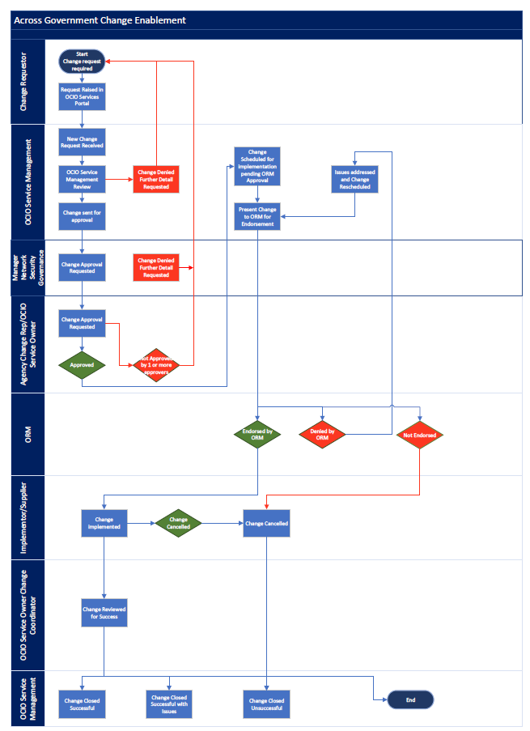
Related documents
- Across Government Change Enablement Flow Chart
- Across Government Change Risk Matrix

Appendix
- Operational Review Meeting (ORM) Roles and Responsibilities
- Operational Review Meeting (ORM) Standard Agenda

Acronyms
Acronym | Words
AGSD | Across Government Service Desk
ORM | Operational Review Meeting
OCIO | Office of the Chief Information Officer
DPC | Department of Premier and Cabinet
ITIL | Information Technology Infrastructure Library

DOCUMENT CONTROL
Approved by: Paul Tracey, Director Infrastructure and Customer Service, Office of the Chief
Information Officer (OCIO)
Contact: OCIO Service Delivery Manager | Email: joanne.romeo@sa.gov.au
Division: Infrastructure and Customer Service | Compliance: Mandatory
Review number: | Date of approval: 28 March 2024
Next review date: March 2025 | Objective Id: B1746792

Appendix A
Operational Review Meeting (ORM) Roles and Responsibilities
Role | Responsibilities
OCIO Service Management Team | - Chairs the meeting.  - Represents the interests of the State.  - Presents information for discussion.  - Arbitrates where the forum cannot reach an agreement.  - Provides Across Government announcements as required.  - Facilitates specialist advice to the meeting on the Across Government Incident Management and Change Management Processes  - Discusses outcomes (minutes and follow-up actions) from the meeting.  - Distributes extract of changes to be reviewed.  - Records Team Meeting and shares on ORM Chanel  - Follow up on actions raised for Changes and Incidents at ORM
Supplier Representative | - Attendance is required.  - Identifies outcomes for across Government Emergency and Late Changes submitted by their organisation.  - Contributes as part of the ‘review panel’ to query aspects of any scheduled across Government Change presented for discussion. This review is regardless of whether a given Supplier is involved in an Across Government Change.  - Identifies any concerns with a given Across Government Change.  - Represents Across Government Changes to the meeting when their organisation is the Change Submitter. Provide a brief description of the Across Government Change highlighting critical aspects such as technical and business risks, backout plan, contingency plans, scheduling, agency notification and business impact.  - Responds to questions raised by meeting attendees regarding Across Government Changes they are representing.  - Ensures Across Government Problem management activities are actioned as directed.  - Accepts and acts on any follow-up action items assigned to them.
Change Agency Representative | - Attendance is required.  - Represents the interests of their agency.  - Identifies and confirms business impact of Across Government Incidents for their agency.  - Confirms and expands upon previously defined business impact of Across Government Changes as required.  - Presents Across Government Changes to the meeting when their agency is the Change Submitter. Provides a brief description of the Across Government Change highlighting critical aspects such as technical and business risks, backout plan, contingency plans, scheduling, agency notification and business impact.

Appendix B
Operational Review Meeting (ORM)
ORM to be held via Microsoft Teams twice weekly on Tuesdays and Thursdays, commencing at 10:00am.
Standard Agenda
Agenda Item | Facilitated By | Contribution | Source
Meeting welcome and kick-off | Chairperson
Across Government Change Enablement | Chairperson
- Review upcoming Across Government Changes requiring endorsement. |  | Supplier Representative  Agency Representative  OCIO Change Coordinator | R1 & R2 Changes Reviewed and Endorsement recorded on OCIO ITSM
- Review of the Forward Schedule of Change including R3. |  | Supplier Representative  Agency Representative  OCIO Change Coordinator | Upcoming changes including R3 Changes are discussed using the OCIO ITSM
- Review Unsuccessful or Successful with Issues Across Government changes reported since last ORM |  | Supplier Representative  OCIO Change Coordinator | Unsuccessful or Successful with Issues Across Government changes discussed.
Across Government Incident Management | Chairperson
- Highlight across Government Incidents logged since last ORM assessing:  - Client Impact  - Status  - Problem Report | Chairperson | Supplier Representative  Agency Representative  OCIO Incident Coordinator  OCIO Service Owner | Display PIR in OCIO ITSM for review.
Other Business | Chairperson
Close Meeting | Chairperson

