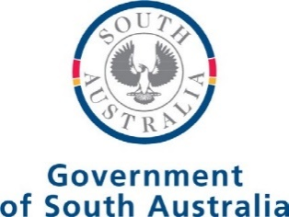

MEDIA PANEL
SECONDARY
PROCUREMENT

CUSTOMER ORDER

LAST UPDATED JULY 2023

Customer Order
The Master Media Scheme Customer Agreement Number B1510294 for the supply of media services between
the Premier of South Australia on behalf of the Crown in the right of the State of South Australia was executed on 20 June 2023.
This Customer Order is subject to the Terms and Conditions made under the Master Media Customer Agreement.

 | Item no. | Item | Particulars
 | 1 | Date of this Customer Order | <Insert date>
 | 2 | Media Panel supplier | <Insert Media Panel supplier name>  <Insert address>  <Insert contact name>
 |  | Customer (Government agency or statutory authority) | <Insert department/agency name>
 |  | ABN | <Insert ABN>
 | 3 |  | <Insert contact name and address for invoicing>
MANDA T OR Y REQUIREMENTS |  | Invoicing address
<Insert project or campaign name as listed on the
Request for Quote Media Brief>
 | 4 | Project/campaign name
 | 5 | Total budget inc GST | <Total media budget as outlined on the Request for Quote Media Brief>
 | 6 | Contract period | Commencement Date: <Insert commencement date>  Expiry Date: <Insert expiry date>
 |  |  | <Insert any further instructions or specifications of the customer order>
 | 7 | Other instructions or specifications
 |  | Confidential Contract Conditions | All rates of the Media Panel are to remain confidential as outlined in the  whole of government Master Media Scheme Customer Agreement.

Execution of Customer Order

Customer
Signed by <insert name and title of procurement delegate>
of <government agency or statutory authority> in the presence of:

Witness signature <insert signature> Print name <insert name>

Signed by <insert name and title> Date <insert date>

Accepted by the Media Panel supplier
Signed by the <insert name of Media Panel supplier> in accordance with s127 of the Corporations Act 2001 by:

Signature <insert name and title> Date <insert date>

