Stakeholder toolkit
This kit is designed to help agencies, councils and community groups to spread the word about the Major Economic Summit in the Upper Spencer Gulf.
It includes social media and website graphics, newsletter content and A4 posters to print and display.

Whyalla | Port Augusta | Port Pirie
25 to 27 February 2024

Social media graphics

Social media (optimised for Facebook and Instagram)
To use: Right click on the image and choose ‘save as picture’, then save and load to your social media platform as normal.
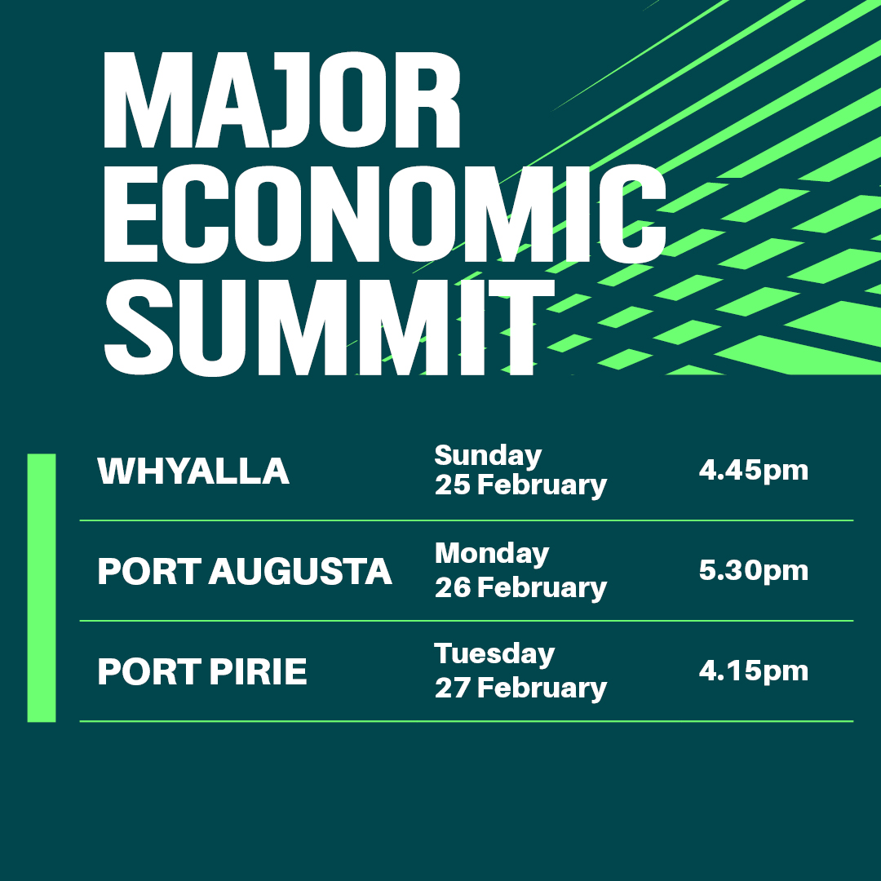
The state government is hosting a Major Economic Summit in the Upper Spencer Gulf this month. Join South Australia’s Premier, Peter Malinauskas, for a free BBQ and public forum to learn more about the exciting economic opportunities in the region.
- Whyalla – 25 February from 4:45pm
- Port Augusta – 26 February from 5:30pm
- Port Pirie – 27 February from 4:15pm
Register to attend at dpc.sa.gov.au/USG
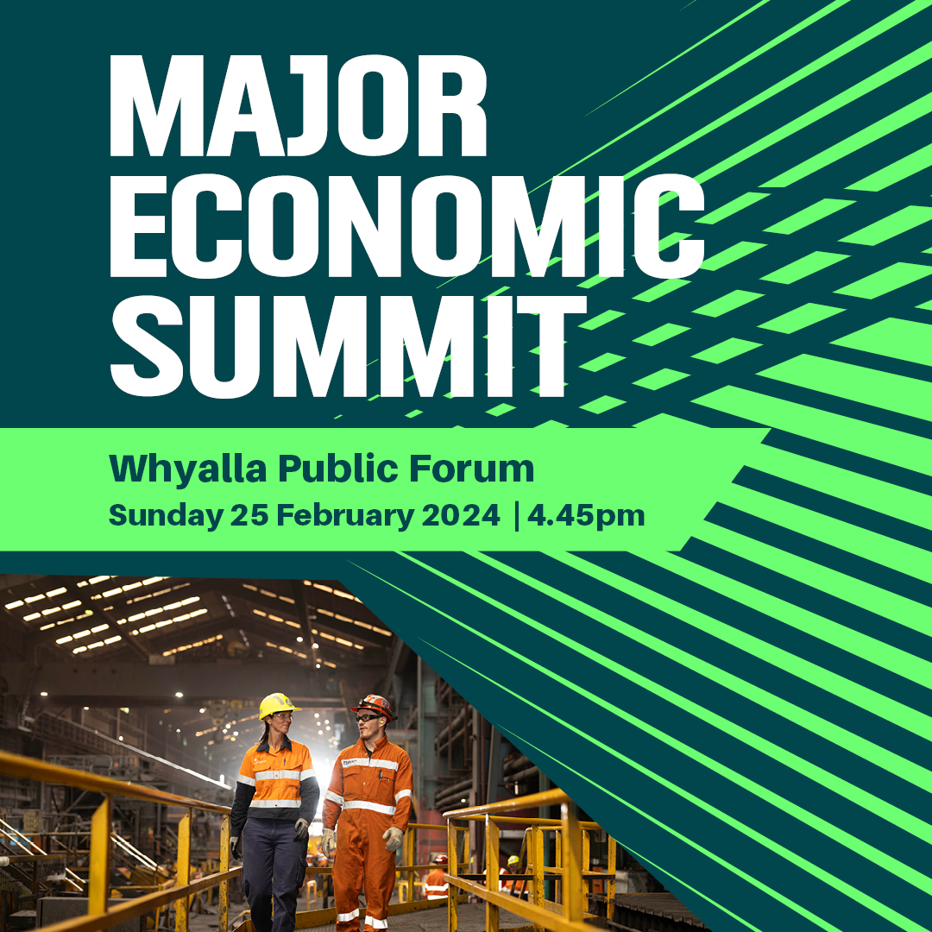
The state government is hosting a Major Economic Summit in the Upper Spencer Gulf this month. Join South Australia’s Premier, Peter Malinauskas, for a free BBQ and public forum in Whyalla on Sunday 25 February from 4:45pm to learn more about the exciting economic opportunities in the region. Register to attend at dpc.sa.gov.au/USG

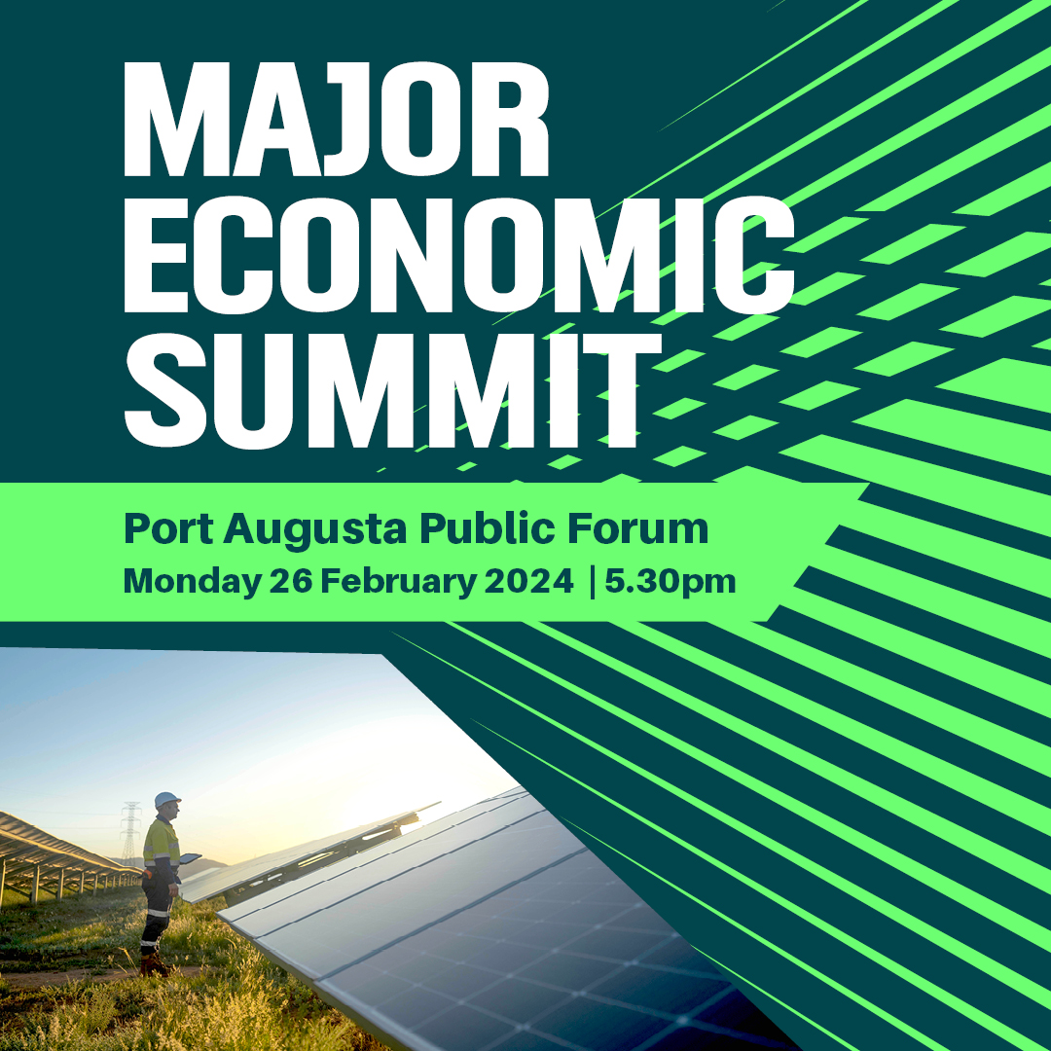
The state government is hosting a Major Economic Summit in the Upper Spencer Gulf this month. Join South Australia’s Premier, Peter Malinauskas, for a free BBQ and public forum in Port Augusta on Monday 26 February from 5:30pm to learn more about the exciting economic opportunities in the region. Register to attend at dpc.sa.gov.au/USG

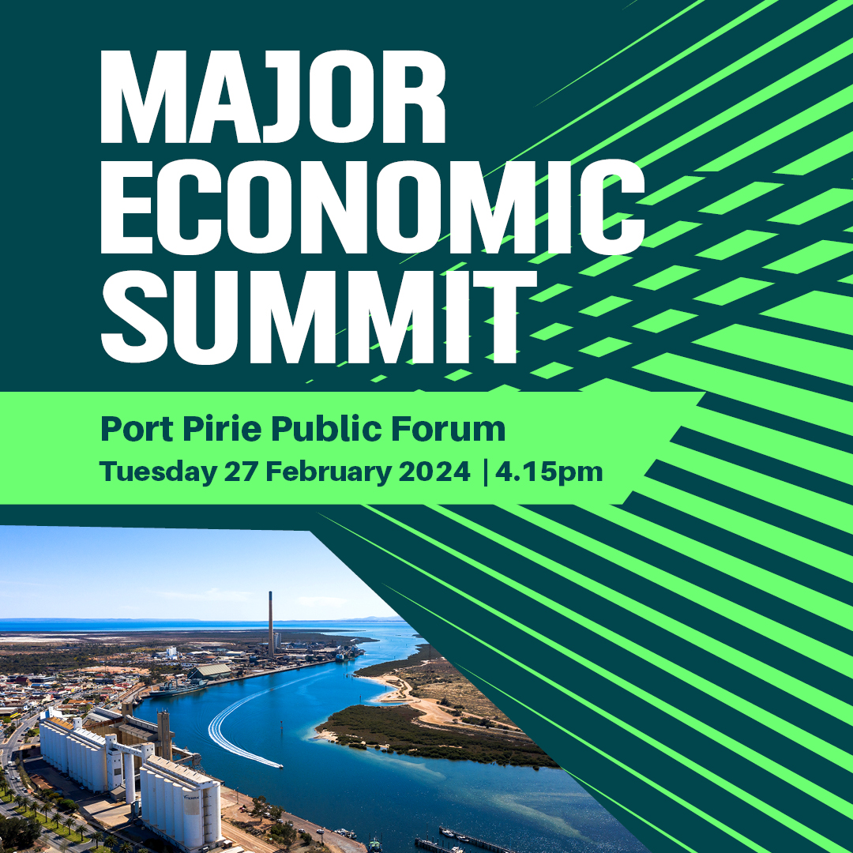
The state government is hosting a Major Economic Summit in the Upper Spencer Gulf this month. Join South Australia’s Premier, Peter Malinauskas, for a free BBQ and public forum in Port Pirie on Tuesday 27 February from 4:15pm to learn more about the exciting economic opportunities in the region. Register to attend at dpc.sa.gov.au/USG

Website/newsletter graphics
To use: Right click on the image and choose ‘save as picture’, then save and load to your platform as normal.
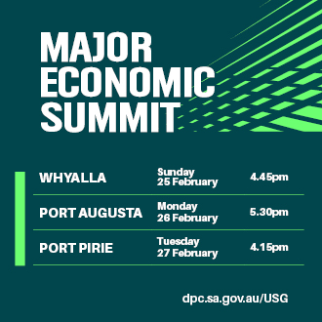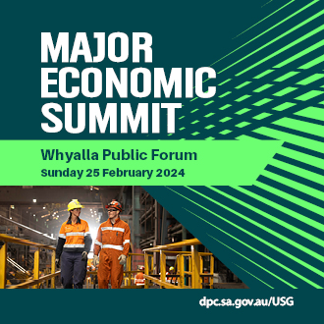
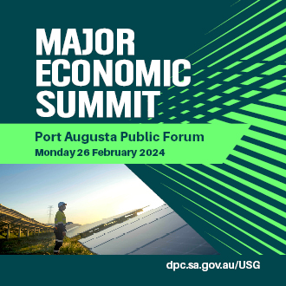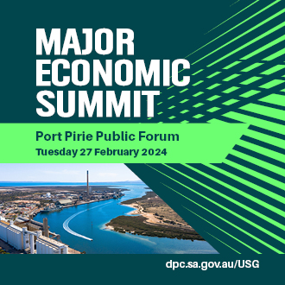

Newsletter content
Learn more about the economic future of the Upper Spencer Gulf
The Premier of South Australia, Hon Peter Malinauskas MP, will visit the Upper Spencer Gulf later this month to host a Major Economic Summit.
The summit will feature three public forums across the region’s key centres – Whyalla on Sunday 25 February, Port Augusta on Monday 26 February and Port Pirie on Tuesday 27 February.
Each event will start with a free community BBQ, followed by a public forum, which will outline our state’s once-in-a-generation opportunity to lead the world in renewable hydrogen energy, green steel and copper production.
[Insert as appropriate: The Whyalla event will be held at the Westland Hotel Motel from 4:45pm. / The Port Augusta event will be held at the central Oval Community Sporting Hub from 5:30pm. / The Port Pirie event will be held at the Port Pirie Sports Precinct from 4:15pm.]
Community members are invited to attend for an opportunity to ask questions, have their say and learn more about the exciting economic future of the region.
Registrations to attend are now open. For more information and to register, visit dpc.sa.gov.au/USG

A4 Posters
To open and print: Double-click on the PDF file icon below to open it in Adobe Acrobat. Please remove it from displays by 27 February 2024.
Whyalla A4 Poster PDF
Port Augusta A4 Poster PDF
Port Pirie A4 Poster PDF

